Assignment 4.1: Software Security Test Plan
Raymond Olmos
University of San Diego
CYBR-510-01B: Security Test Engineering
Professor Mark Heckman
September 28, 2026

Executive Summary
This assignment assessed the DBABA application against five defined security requirements and documented the results through structured test cases, application testing and static code analysis utilizing Pylint. It covered account lockout, credential complexity, access rights, authentication and protection of sensitive information.

- Scope and Test
Testing was performed on DBABA Python application and ABA Command Line Interface Specification v1.3.2. Tests were conducted on synthetic accounts and data from a Linux terminal were carried out. The task was to categorize failures as either interface specification deficiency or program deficiency.
- Security Requirements
ID | Requirement | Assignment Security Intent
SR-1 | Login Credential complexity | Require non trivial, unpredictable login credentials to mitigate guessing dictionary, and brute force attacks
SR-2 | Account lockout | After three consecutive incorrect login attempts, generate an alarm and lock the account for one minute
SR-3 | Authentication | Require users to authenticate before granting access to system resources
SR-4 | Access rights | Allow access to system resources only to authenticated users with proper authorization
SR-5 | Sensitive Information protection | Protect sensitive information from unauthorized disclosure while stored or in transit

- Test Scenario Summary
Scenario ID | Security requirement | Scenario | Priority | Test-case IDs
TS-01 | SR-1 | Verify password creation and password changes reject weak, invalid, or out-of-range credentials and accept a valid non-trivial credential. | High | TC-01 through TC-06
TS-02 | SR-2 | Verify that three consecutive invalid login attempts trigger an alarm and a 60-second account lockout. | Critical | TC-07 through TC-10
TS-03 | SR-3 | Verify that unauthenticated users cannot access address-book, account-administration, or audit-log resources. | Critical | TC-11 through TC-17
TS-04 | SR-3 | Verify that authentication cannot be bypassed through account-name manipulation in the LIN command. | Critical | TC-18 through TC-19
TS-05 | SR-4 | Verify that normal users cannot perform administrator-only commands. | Critical | TC-20 through TC-24
TS-06 | SR-4 | Verify that the administrator cannot access, create, modify, delete, import, or export confidential information. | Critical | TC-25 through TC-31.
TS-07 | SR-4 | Verify that Alice cannot access, modify, delete, import into, or export Ben’s confidential information. | Critical | TC-32 through TC-36
TS-08 | SR-5 | Verify that stored credentials and CI are protected from unauthorized local disclosure. | Critical | TC-37 through TC-40
TS-09 | SR-5 | Verify that error messages and audit logs do not disclose passwords or unnecessary CI. | High | TC-41 through TC-43

- Test Cases
Test Case ID | Requirement | Command | Expected result
TC-1 | SR-1 | LIN weak1; enter password at both first-time password prompts. | Password is rejected as too easy to guess; no authenticated session begins. See figure 9.
TC-2 | SR-1 | LIN weak2; entered 12345678 at both first-time password prompts. | Password is rejected as too easy to guess; no authenticated session begins. See figure 9.
TC-3 | SR-1 | LIN short1; entered Abc123 at both first-time password prompts. | Password is rejected because it is shorter than the eight-character minimum stated in the account-identification specification. See figure 9.
TC--4 | SR-1 | LIN good1; entered CedarLake27 at both first-time password prompts. | Password is accepted; the application returns OK and begins a session for good. See figure 10.
TC-5 | SR-1 | LIN long1; entered Abcdefghijklmnopqrstuvwxy at both first-time password prompts. | Password is rejected because it exceeds the 24-character maximum. See figure 11.
TC-6 | SR-1 | LIN special1; entered TestPass1! at both first-time password prompts. | Password is rejected because the ABA specification permits only upper- and lower-case letters and numbers.
TC-7 | SR-2 | With no active session, run LIN alice three times and enter WrongPass1, WrongPass2, and WrongPass3 at the respective password prompts. | On the third consecutive incorrect password attempt, the ABA generates an alarm and locks Alice’s account for 60 seconds.
TC-8 | SR-2 | Immediately after the third failed login, ran LIN alice and entered Alice’s correct password. | Login is denied because Alice’s account remains locked for 60 seconds. See figure 12.
TC-9 | SR-2 | Wait 60 seconds after the expected third-failure lockout, then run LIN alice with Alice’s correct password. | A valid login is accepted after the previously enforced 60-second lockout expires. See figure 12.
TC-10 | SR-2 | Make two invalid login attempts, successfully authenticate, log out, then make one additional invalid attempt. | The successful authentication resets the failed-attempt counter; the next single failed attempt does not trigger lockout.
TC-11 | SR-3 | ADR TestRecord SN=Test while no session is active | No active login session; no record created
TC-12 | SR-3 | RER APrivate while no session is active | No active login session; no CI displayed
TC-13 | SR-3 | REA while no session is active | No active login session; no CI displayed
TC-14 | SR-3 | IMD test.csv while no session is active | No active login session; no import occurs
TC-15 | SR-3 | EXD unauth_export.csv while no session is active | No active login session; no export file is created
TC-16 | SR-3 | ADU hacker while no session is active | No active login session; no account is created
TC-17 | SR-3 | RAL while no session is active | No active login session; no audit data displayed
TC-18 | SR-3 | LOU, then LIN ben; when prompted, enter Alice’s password, not Ben’s password. Then enter WAI. | Invalid credentials; no Ben session is created; WAI should show no active user.
TC-19 | SR-3 | LOU, then LIN admin; when prompted, enter Alice’s password, not AdminTest. If login succeeds, enter WAI and LSU. | Invalid credentials; no administrator session is created; LSU must not run successfully.
TC-20 | SR-4 | ADU hacker | Admin not active; no account created
TC-21 | SR-4 | DEU ben | Admin not active; Ben remains an account
TC-22 | SR-4 | LSU | Admin not active; account list not disclosed
TC-23 | SR-4 | RAL | Admin not active; audit log not disclosed
TC-24 | SR-4 | DAL | Admin not active; audit log remains unchanged
TC-25 | SR-4 | ADR AdminRecord SN=Admin | Admin not authorized; no record created
TC-26 | SR-4 | RER APrivate | Admin not authorized; no CI displayed
TC-27 | SR-4 | REA | Admin not authorized; no CI displayed
TC-28 | SR-4 | DER APrivate | Admin not authorized; no record deleted
TC-29 | SR-4 | EDR APrivate SN=Changed | Admin not authorized; Alice’s record remains sn=Alpha
TC-30 | SR-4 | IMD test.csv | Admin not authorized; no import occurs
TC-31 | SR-4 | EXD admin_export.csv | Admin not authorized; no export file is created
TC-32 | SR-4 | RER BenPrivate as Alice | No record found; Ben’s CI not displayed.
TC-33 | SR-4 | EDR BenPrivate SN=Hacked as Alice | RecordID not found; no modification occurs.
TC-34 | SR-4 | DER BenPrivate | RecordID not found; Ben’s record is not deleted.
TC-35 | SR-4 | REA | OK and only Alice’s records are displayed. Ben’s BenPrivate record does not appear.
TC-36 | SR-4 | LOU, then LIN ben, enter Ben’s password, then RER BenPrivate | OK; BenPrivate is displayed with sn=Smith and gn=Ben. The surname must not be Hacked, and the record must not be missing.
TC-37 | SR-5 | cat abapwfile | Password file contains user IDs and salted password hashes; no plaintext test passwords appear.
TC-38 | SR-5 | Created salt1 and salt2; assigned both the same permitted lab password; exited DBABA; ran grep -E '^(salt1\|salt2):' abapwfile. | salt1 and salt2 have different stored bcrypt hash strings despite using the same password, demonstrating unique salts. See figure 14.
TC-39 | SR-5 | ls -l dbadb-db; file dbadb-db; sqlite3 dbadb-db \"SELECT uname, recordid, sn, gn, pem, sa FROM AbaTable;\" | CI storage is protected from unauthorized local disclosure through restrictive permissions and appropriate data protection. See figure 13.
TC-40 | SR-5 | Logged in as Alice; executed EXD alice_export.csv; exited DBABA; ran ls -l alice_export.csv and cat alice_export.csv. | The export contains only Alice’s CI and is protected with restrictive file permissions so unauthorized local users cannot read it. See figure 15.
TC-41 | SR-5 | Started DBABA; logged in as admin; executed RAL. | Audit records contain only date, time, audit event type, and user ID; passwords, password hashes, and full CI fields are not disclosed. See figure 16.
TC-42 | SR-5 | As Alice, executed RER InvalidID, EDR APrivate BADFIELD=value, and IMD missing.csv. | Controlled errors are returned. No passwords, password hashes, other users’ CI, Python stack traces, internal database schema, or unnecessary file paths are disclosed. See figure 17.
TC-43 | SR-5 | Reviewed the DBABA command set and current standalone test environment for network-based CI transfer functionality. | If no ABA network-transfer feature exists, document that encryption-in-transit testing is not applicable to the current build. If network transfer exists, CI must be encrypted in transit.

- Test Execution Results
Test Case ID | SR | Command | Actual result | Status
TC-1 | SR-1 | LIN weak1; enter password at both first-time password prompts. | Password is too easy to guess | Pass
TC-2 | SR-1 | LIN weak2; entered 12345678 at both first-time password prompts. | Password is too easy to guess | Pass
TC-3 | SR-1 | LIN short1; entered Abc123 at both first-time password prompts. | DBABA accepted Abc123 and returned OK, creating an authenticated session for short1. | Fail
TC--4 | SR-1 | LIN good1; entered CedarLake27 at both first-time password prompts. | DBABA accepted CedarLake27 and returned OK, establishing a session for good1. | Pass
TC-5 | SR-1 | LIN long1; entered Abcdefghijklmnopqrstuvwxy at both first-time password prompts. | DBABA displayed Password must be 1-24 alphanumeric characters and rejected the 25-character password. No authenticated session was created. | Pass
TC-6 | SR-1 | LIN special1; entered TestPass1! at both first-time password prompts. | DBABA displayed Password must be 1-24 alphanumeric characters and rejected the password containing !. No authenticated session was created. | Pass
TC-7 | SR-2 | With no active session, run LIN alice three times and enter WrongPass1, WrongPass2, and WrongPass3 at the respective password prompts. | Figure 8. Three consecutive invalid login attempts did not generate an alarm or account lockout. | Fail
TC-8 | SR-2 | Immediately after the third failed login, ran LIN alice and entered Alice’s correct password. | The correct password was accepted and DBABA returned OK; Alice successfully authenticated immediately after three consecutive failed login attempts. | Fail
TC-9 | SR-2 | Wait 60 seconds after the expected third-failure lockout, then run LIN alice with Alice’s correct password. | Not applicable: DBABA did not initiate an account lockout after three failed attempts; therefore, lockout expiration could not be tested. | N/A
TC-10 | SR-2 | Make two invalid login attempts, successfully authenticate, log out, then make one additional invalid attempt. | Not applicable: DBABA did not demonstrate any failed-login counter or account-lockout behavior during TC-07 and TC-08. | N/A
TC-11 | SR-3 | ADR TestRecord SN=Test while no session is active | Observed “No active login session”; no record was created. See Figure 1. | Pass
TC-12 | SR-3 | RER APrivate while no session is active | Observed “No active login session”; no record was created. See Figure 1. | Pass
TC-13 | SR-3 | REA while no session is active | Observed “No active login session”; no record was created. See Figure 1. | Pass
TC-14 | SR-3 | IMD test.csv while no session is active | Observed “No active login session”; no record was created. See Figure 1. | Pass
TC-15 | SR-3 | EXD unauth_export.csv while no session is active | Observed “No active login session”; no record was created. See Figure 1. | Pass
TC-16 | SR-3 | ADU hacker while no session is active | Observed “No active login session”; no hacker account was created. See Figure 2. | Pass
TC-17 | SR-3 | RAL while no session is active | Observed “No active login session”; no hacker account was created. See Figure 2. | Pass
TC-18 | SR-3 | LOU, then LIN ben; when prompted, enter Alice’s password, not Ben’s password. Then enter WAI. | LIN ben returned Invalid credentials. WAI displayed Current user is None, and REA returned No active login session. | Pass
TC-19 | SR-3 | LOU, then LIN admin; when prompted, enter Alice’s password, not AdminTest. If login succeeds, enter WAI and LSU. | LIN admin returned Invalid credentials. WAI displayed Current user is None; no administrator session was created. | Pass
TC-20 | SR-4 | ADU hacker | Admin not active; no hacker account was created. See figure 3. | Pass
TC-21 | SR-4 | DEU ben | Admin not active; no hacker account was created. See figure 3. | Pass
TC-22 | SR-4 | LSU | Admin not active; no hacker account was created. See figure 3. | Fail
TC-23 | SR-4 | RAL | Admin not active; no hacker account was created. See figure 3. | Pass
TC-24 | SR-4 | DAL | Admin not active; no hacker account was created. See figure 3. | Pass
TC-25 | SR-4 | ADR AdminRecord SN=Admin | Observed “Admin not authorized”; no administrator record was created. | Pass
TC-26 | SR-4 | RER APrivate | Observed “Admin not authorized”; no CI was displayed. | Pass
TC-27 | SR-4 | REA | Observed Admin not authorized | Pass
TC-28 | SR-4 | DER APrivate | Observed Admin not authorized | Pass
TC-29 | SR-4 | EDR APrivate SN=Changed | No completion status was displayed; after logging in as Alice, RER APrivate showed sn=Alpha, confirming no modification. | Fail
TC-30 | SR-4 | IMD test.csv | Observed Admin not authorized | Pass
TC-31 | SR-4 | EXD admin_export.csv | Observed Admin not authorized | Pass
TC-32 | SR-4 | RER BenPrivate as Alice | No record found; Ben’s CI was not displayed. See figure 6. | Pass
TC-33 | SR-4 | EDR BenPrivate SN=Hacked as Alice | The application returned directly to the ABA> prompt with no completion status or RecordID not found message. See figure 6. | Fail
TC-34 | SR-4 | DER BenPrivate | RecordID not found. See figure 7. | Pass
TC-35 | SR-4 | REA | OK; APrivate, sn=Alpha, gn=Alice. See figure 7. | Pass
TC-36 | SR-4 | LOU, then LIN ben, enter Ben’s password, then RER BenPrivate | OK; BenPrivate was displayed with sn=Smith and gn=Ben. The record remained present and unchanged after Alice’s attempted actions. See figure 7. | Pass
TC-37 | SR-5 | cat abapwfile | abapwfile contained account names followed by bcrypt-formatted values beginning with $2a$12$ for accounts with established passwords. No plaintext test passwords were visible. Accounts whose password setup was rejected had empty password fields. | Pass
TC-38 | SR-5 | Created salt1 and salt2; assigned both the same permitted lab password; exited DBABA; ran grep -E '^(salt1\|salt2):' abapwfile. | salt1 stored $2a$12$DPKjfItDlTxpsZFSovQpDOTJnvvBwRXyUQHP.c9B0xhfupn5/xH52; salt2 stored $2a$12$XVnjADvXR.cE/hHvUQd73ehssp3tA/e1BRGASbX./QgXEk1rAfoHK. The two bcrypt values differ. | Pass
TC-39 | SR-5 | ls -l dbadb-db; file dbadb-db; sqlite3 dbadb-db \"SELECT uname, recordid, sn, gn, pem, sa FROM AbaTable;\" | dbadb-db was identified as a SQLite 3 database and had -rw-r--r-- permissions, allowing other local users to read it. SQLite queries returned plaintext CI for Alice and Ben, including record IDs, names, email addresses, and street addresses, without DBABA authentication. | Fail
TC-40 | SR-5 | Logged in as Alice; executed EXD alice_export.csv; exited DBABA; ran ls -l alice_export.csv and cat alice_export.csv. | The export contained only Alice’s record, APrivate, and did not include Ben’s CI. However, alice_export.csv was created with permissions -rw-rw-r--, allowing other local users to read plaintext CI. The file contained Alice’s name, email address, phone number, street address, and other contact data. | Fail
TC-41 | SR-5 | Started DBABA; logged in as admin; executed RAL. | RAL returned OK and displayed audit entries containing timestamps, event types (LF, LS, AU, DU, and LO), and user IDs. No plaintext passwords, bcrypt hashes, contact names, email addresses, phone numbers, or street addresses appeared. | Pass
TC-42 | SR-5 | As Alice, executed RER InvalidID, EDR APrivate BADFIELD=value, and IMD missing.csv. | RER InvalidID returned No record found; EDR APrivate BADFIELD=value returned no completion status; IMD missing.csv returned File doesn't exist. None of the outputs disclosed passwords, bcrypt hashes, Ben’s CI, Python tracebacks, database schema information, or internal paths. | Pass
TC-43 | SR-5 | Reviewed the DBABA command set and current standalone test environment for network-based CI transfer functionality. | DBABA operates as a local command-line application with no implemented network interface, network-transfer command, or remote connection capability in the provided build. No CI is transmitted by the application over a network. | N/A

- Screen capture
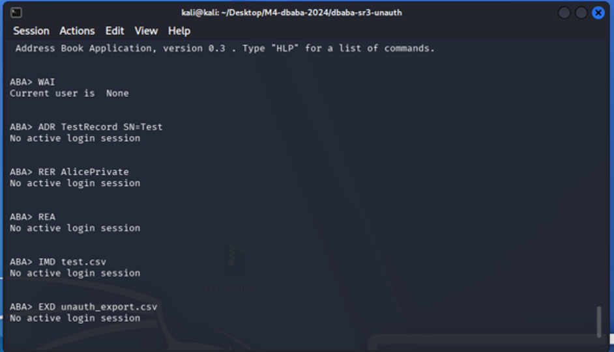
Figure 1
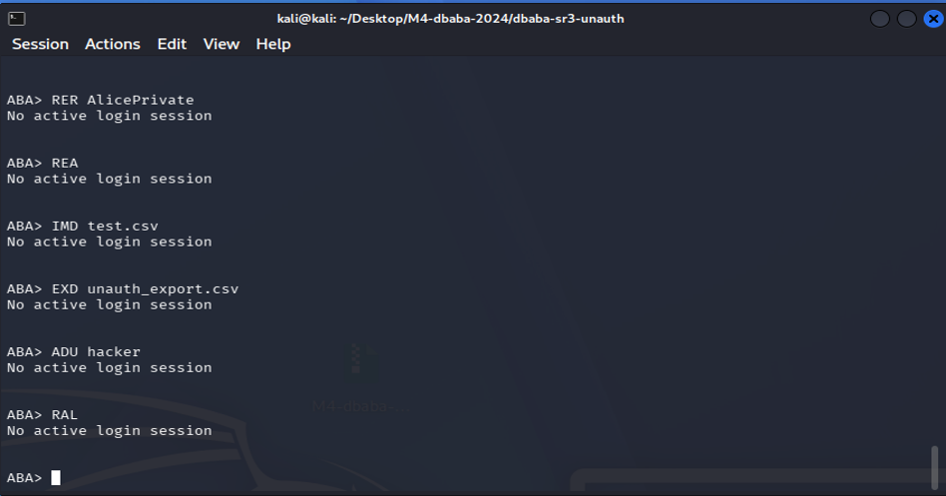
Figure 2
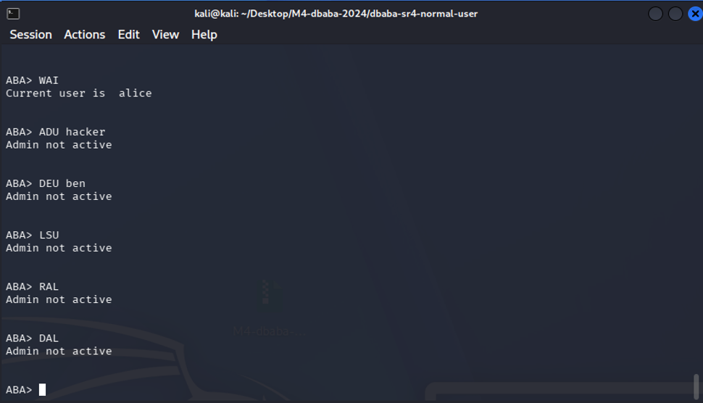
Figure 3
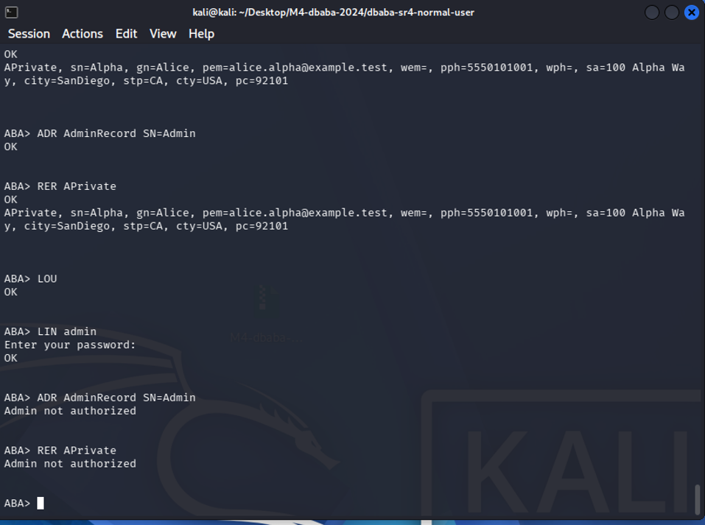
Figure 4
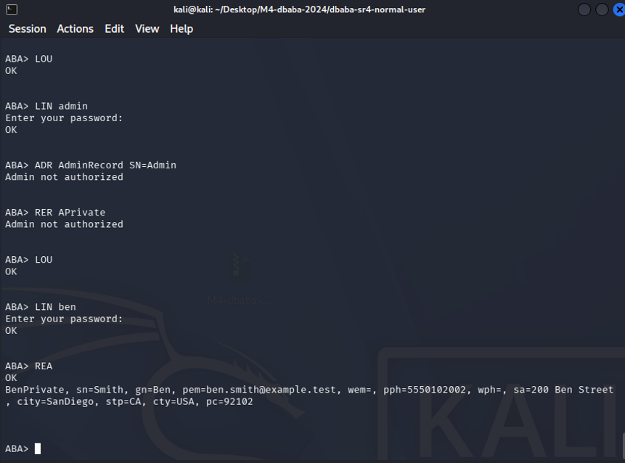
Figure 5

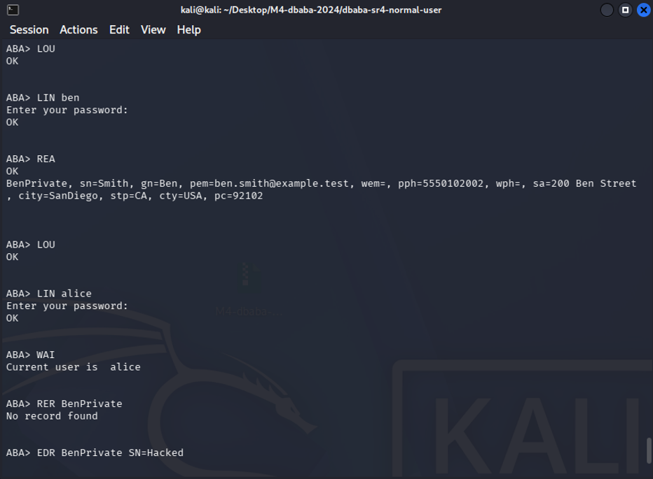
Figure 6
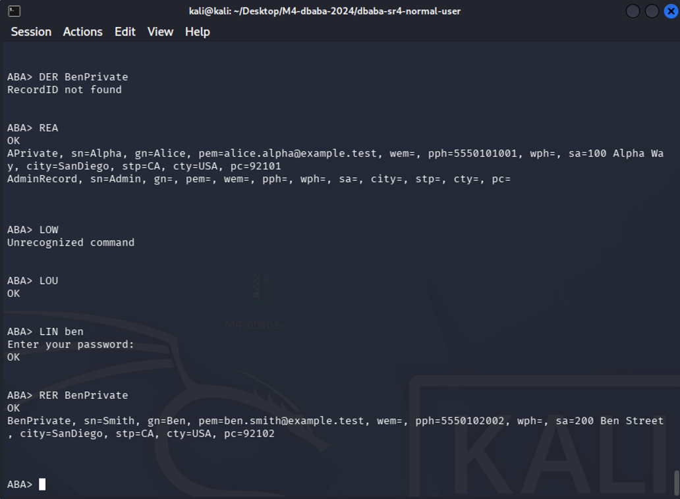
Figure 7
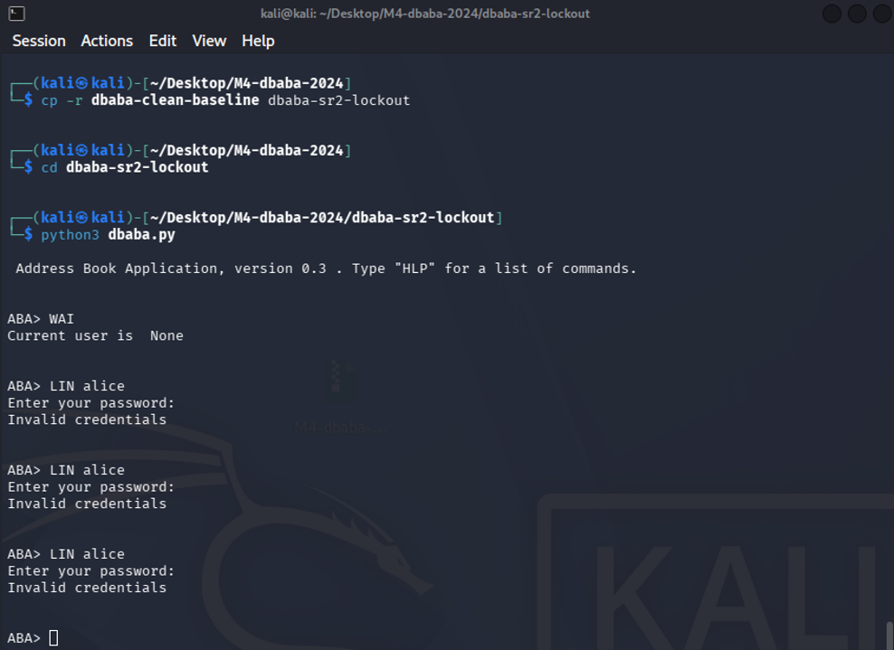
Figure 8
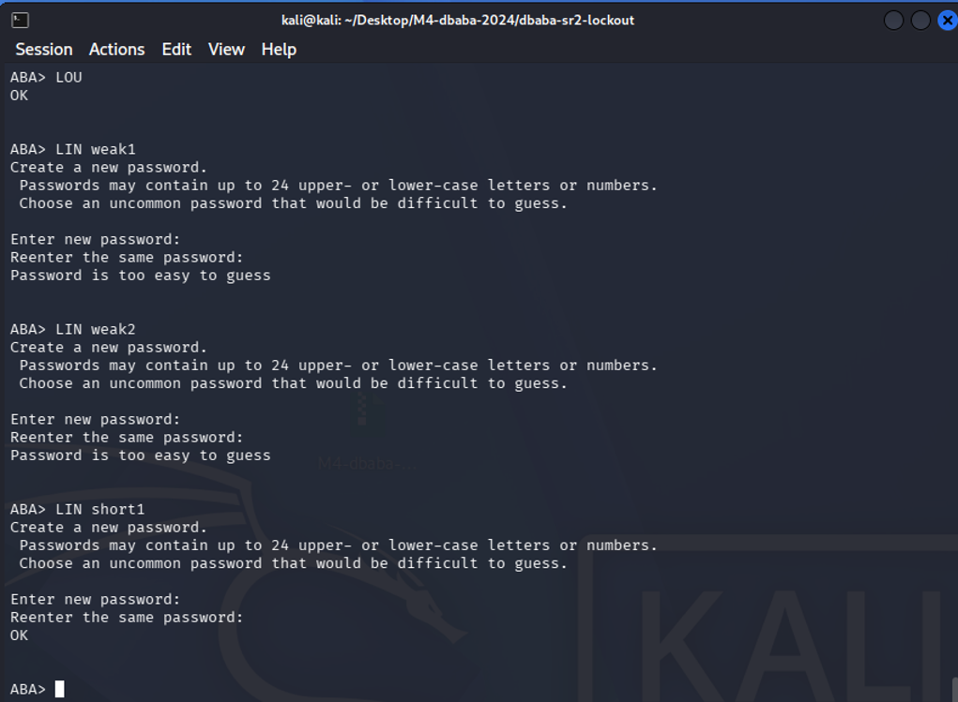
Figure 9
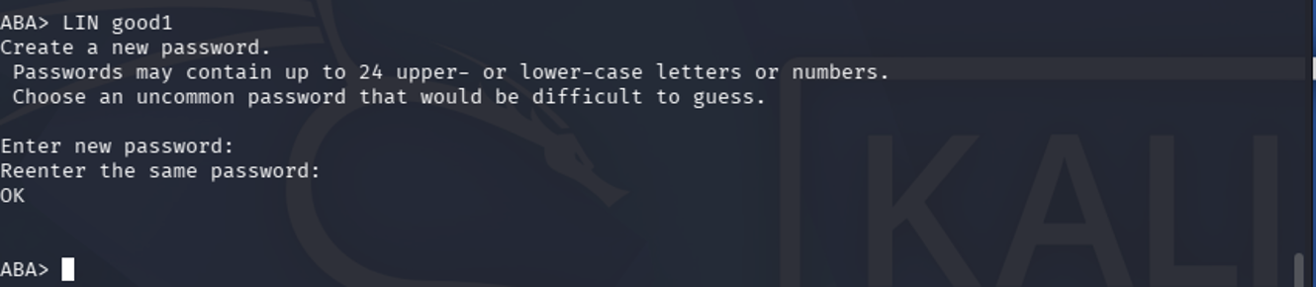
Figure 10
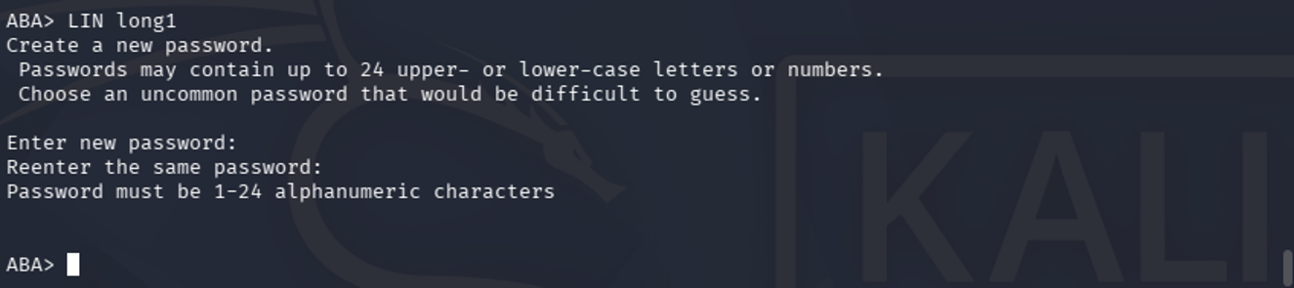
Figure 11
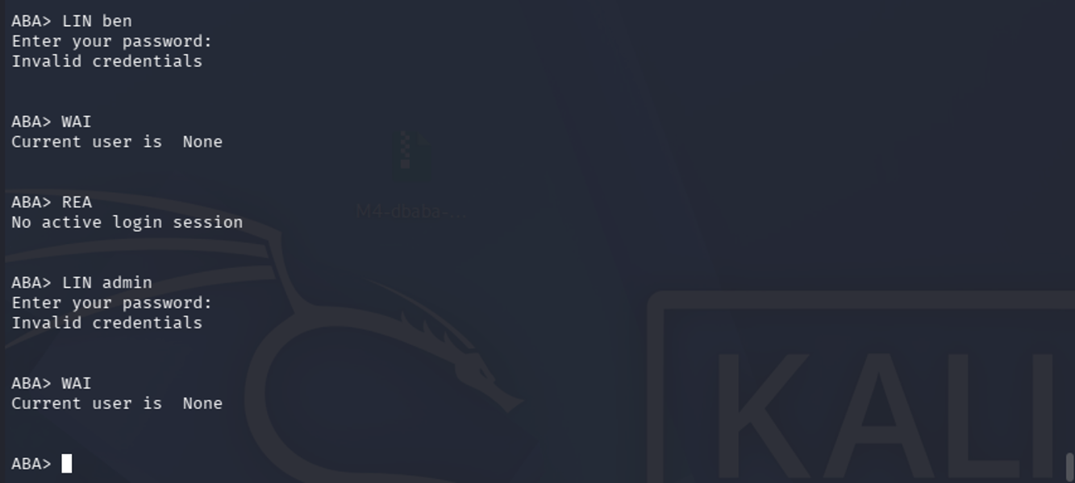
Figure 12
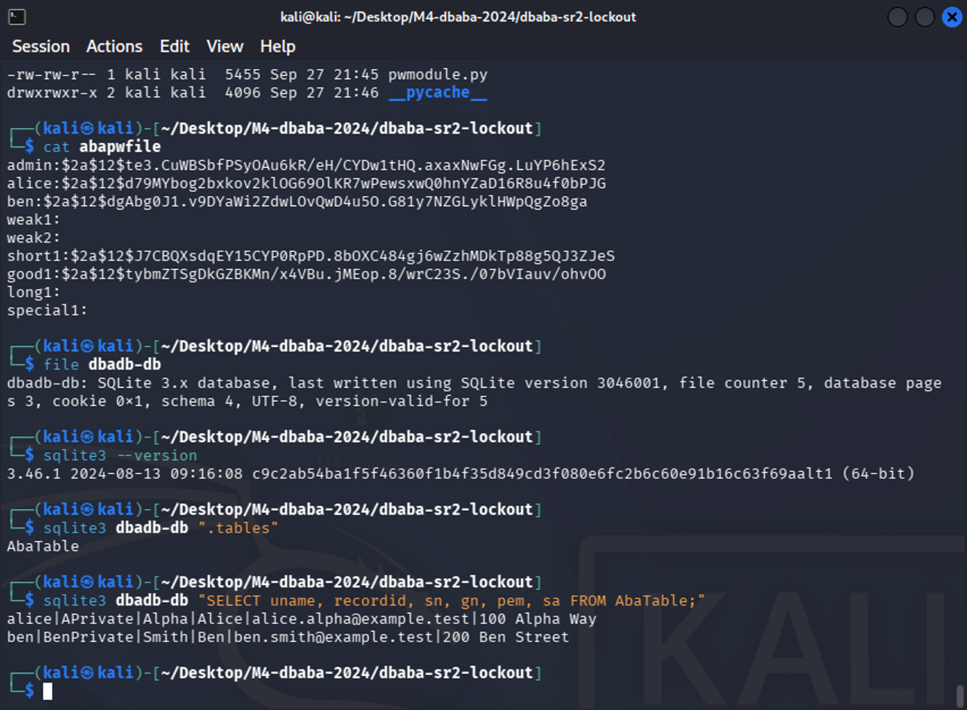
Figure 13
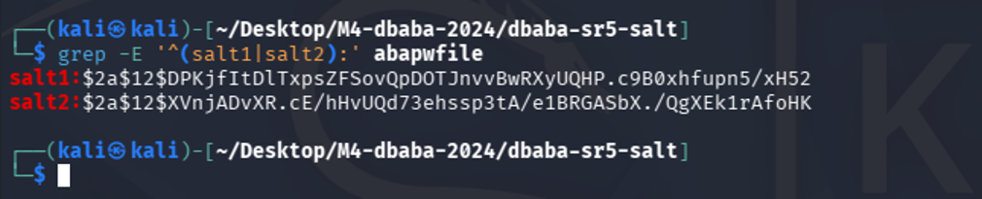
Figure 14
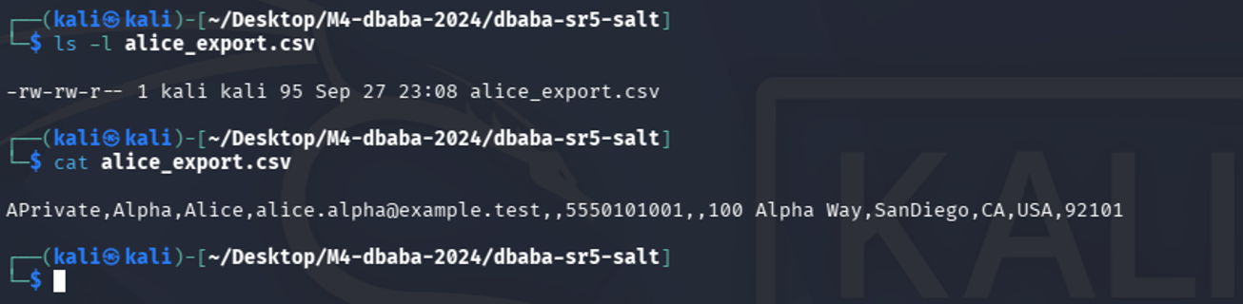
Figure 15
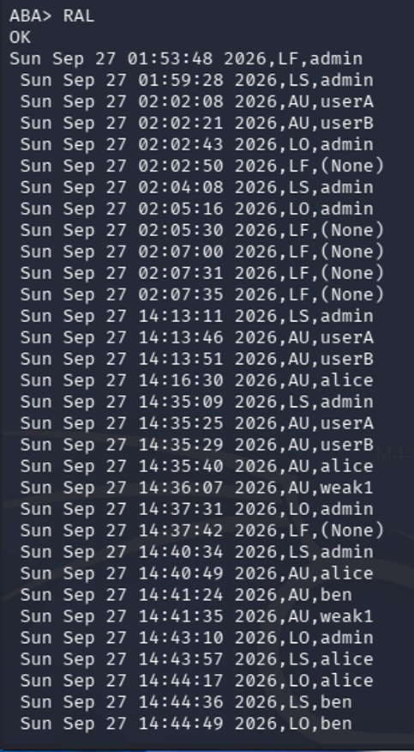
Figure 16
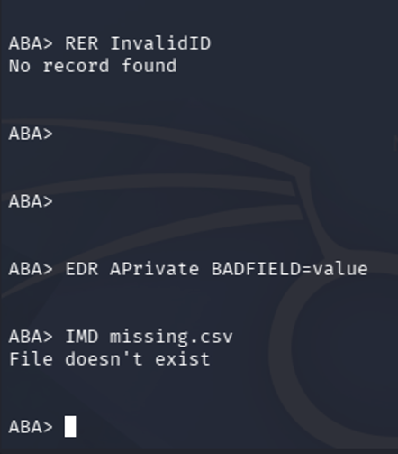
Figure 17
- Traceability Report
Security requirement | Scenario IDs | Test-case IDs | Execution summary | Defects
SR-1 | TS-01 | TC-01–TC-06 | 5 Pass, 1 Fail | DEF-SR1-PASSWORD-LENGTH-001
SR-2 | TS-02 | TC-07–TC-10 | 2 Fail, 2 N/A | DEF-SR2-LOCKOUT-001
SR-3 | TS-03, TS-04 | TC-11–TC-19 | All executed cases passed | None confirmed
SR-4 | TS-05, TS-06, TS-07 | TC-20–TC-36 | 14 Pass; 3 Fail: normal user account enumeration through LSU, missing administrator-denial result for EDR, and missing cross-user record-not-found result for EDR. | DEF-SR4-LSU-001; DEF-SR4-EDR-001; DEF-SR4-EDR-002
SR-5 | TS-08, TS-09 | TC-37–TC-43 | 4 Pass, 2 Fail, 1 N/A | DEF-SR5-STORAGE-001; DEF-SR5-EXPORT-001

- Defect Report
Defect ID | SR | Evidence in your work | Assessment
DEF-SR1-PASSWORD-LENGTH-001 | SR-1 | DBABA accepts six-character passwords even though the account-identification specification states passwords must be 8–24 characters. | Specification inconsistency and implementation/security defect
DEF-SR2-LOCKOUT-001 | SR-2 | DBABA does not generate an alarm or lock an account for 60 seconds after three consecutive failed login attempts. | Specification deficiency and implementation defect
DEF-SR4-LSU-001 | SR-4 | A normal authenticated user can execute LSU and enumerate all ABA user accounts. | Implementation defect
DEF-SR4-EDR-001 | SR-4 | EDR blocks an administrator’s record-edit attempt but does not return the required Admin not authorized completion code. | Implementation / interface-conformance defect
DEF-SR4-EDR-002 | SR-4 | EDR blocks Alice from editing Ben’s record but does not return the required RecordID not found completion code. | Implementation / interface-conformance defect
DEF-SR4-EDR-003 | SR-4 | EDR silently rejects an unrecognized record-field identifier instead of returning the documented invalid-field completion code. | Implementation / interface-conformance defect
DEF-SR5-STORAGE-001 | SR-5 | The dbadb-db database is readable in plaintext by unauthorized local users through ordinary filesystem permissions and direct SQLite access. | Implementation and configuration defect

- Pylint Static Code Test
Pylint ID | Observed finding | Relevance
E0601 used-before-assignment | At line 688, Pylint reports that impfile may be used before it has been assigned. | High reliability relevance. A program path that reaches this use without assigning impfile can raise UnboundLocalError, interrupting file import processing. This should be reviewed and corrected before production use.
W0106 expression-not-assigned | At line 517, completion_code == db.Insert_record(list(tmprecorddict.values())) compares two values but does not store or act on the result. | High logic relevance. This may be an accidental use of == where = was intended. If so, the database insertion result may not be captured or processed, potentially leading to unreliable record-processing behavior.
W0104 pointless-statement | Statements at lines 192, 501, 519, 712, 720, and 726 appear to have no effect. | High logic/reliability relevance. These may be incomplete conditions, unused comparisons, or omitted assignments. Each should be inspected because intended validation, error handling, or completion-code processing may not occur.
W0718 broad-exception-caught | The program catches the general Exception type at lines 122, 129, 682, 762, and 779. | Medium security and reliability relevance. Catching every exception can conceal programming errors and operational failures, making security-relevant failures harder to detect and audit. Catch only expected exception types and log or return appropriate errors.
W1514 unspecified-encoding | Files are opened without explicitly specifying an encoding at lines 679 and 761. | Medium reliability relevance. Behavior can vary by operating system or locale when a file contains non-ASCII characters. Explicitly specify an encoding, normally encoding="utf-8".
R1732 consider-using-with | File resources opened at lines 679 and 761 are not managed with with. | Medium resource-management relevance. An exception can leave files open or delay file closure. Use with open(path, "r", encoding="utf-8") as file_handle: so files close reliably.
C0121 singleton-comparison | The code compares values using cur_usr != None and first == True at lines 173, 192, and 200. | Low-to-medium logic relevance. These comparisons are non-idiomatic and can make intent unclear. Use is not None for None, and if first: when testing truth. Clear conditional logic improves validation and authorization review.
R1703 simplifiable-if-statement | At line 53, an if statement can be simplified to return bool(test). | Low maintainability relevance. The logic is more complicated than necessary, increasing review effort. This is not necessarily a functional defect.
R1705 no-else-return | At line 53, an else follows a return and can be removed. | Low maintainability relevance. Removing the unnecessary else improves readability and makes execution paths easier to review.
R1723 no-else-break | At lines 367, 466, and 710, an else follows a break. | Low maintainability relevance. The else is unreachable or unnecessary after break; simplifying it makes loop logic easier to audit.
R1724 no-else-continue | At line 693, an else follows a continue. | Low maintainability relevance. The code can be de-indented and simplified, making file-import control flow clearer.
R1714 consider-using-in | At line 710, multiple comparisons can be consolidated using in or not in. | Low maintainability relevance. Simplifying the condition reduces duplication and the chance of future comparison errors.
C0200 consider-using-enumerate | At line 505, the code iterates using range() and len() instead of enumerate(). | Low maintainability relevance. enumerate() is clearer and reduces indexing mistakes in record-processing loops.
C0206 consider-using-dict-items | At lines 577 and 638, the code iterates over dictionary keys and then accesses values separately. | Low maintainability relevance. Using .items() is clearer and can reduce key/value handling mistakes.
W0612 unused-variable | Variables e, emptyparamdict, tmprecordlist, and discard are assigned but not used. | Low-to-medium reliability relevance. Unused variables can indicate incomplete logic, abandoned error handling, or code paths that were not finalized. Review whether the intended handling or validation was omitted.
R0912 too-many-branches | Functions beginning around lines 345, 441, 531, 661, and 796 exceed Pylint’s branch-complexity threshold; examples include 16, 23, 13, 19, and 30 branches. | Medium maintainability and security-review relevance. Large decision structures are difficult to test exhaustively. They increase the chance that an authorization, validation, or error condition is missed. Refactor into smaller focused functions.
R1702 too-many-nested-blocks | Code around lines 484 and 686 contains 6–7 nested blocks, exceeding the configured maximum of 5. | Medium maintainability relevance. Deep nesting makes important security checks and error paths hard to follow. Reducing nesting can make the import and record-processing logic more reliable.
R0915 too-many-statements | The function beginning at line 796 contains 88 statements, exceeding the threshold of 50. | Medium maintainability relevance. A large function is difficult to test and change safely. Separate command dispatch, validation, authorization, and output handling into smaller methods.
R1722 consider-using-sys-exit | At lines 802, 825, and 906, the code uses an alternative to sys.exit. | Low maintainability relevance. sys.exit() communicates program termination intent more clearly and supports consistent exit behavior.
C0114 missing-module-docstring | The module has no top-level docstring at line 1. | Low documentation relevance. A module docstring would explain the application’s purpose, main assumptions, and major components, improving secure maintenance and code review.
C0116 missing-function-docstring | Numerous functions lack docstrings, including routines near lines 27, 40, 51, 66, 85, 115, 141, 167, 212, 235, 252, 272, 292, 309, 332, 345, 416, 441, 531, 596, 661, 741, and 796. | Low-to-medium maintainability relevance. Missing documentation makes it harder to understand security assumptions, command behavior, required authorization, inputs, outputs, and error outcomes.
C0103 invalid-name | Functions such as AbaStartup, GoodRecordID, StrongPassword, and GetCommand, plus variable targetUsr, do not use snake_case naming. | Low style and maintainability relevance. Inconsistent naming is not a direct vulnerability, but predictable conventions improve code readability and reduce maintenance errors.
C0301 line-too-long | Numerous lines exceed the configured 100-character limit. The most extreme is line 68, reported at 2,214 characters. | Low-to-medium maintainability relevance. Very long lines are difficult to inspect, review, and modify; the 2,214-character password-validation line especially warrants refactoring because it may conceal difficult-to-test logic.
C0303 trailing-whitespace | Trailing whitespace appears on multiple lines, including 19, 188, 219, 294, 339, 410, 501, 502, 505, 510, 568, 629, 688, 709, 787, 806, 898, 899, 907, and 908. | Low code-quality relevance. This does not usually affect execution but indicates inconsistent formatting and creates unnecessary version-control differences.
C0325 superfluous-parens | Unnecessary parentheses appear after return, if, not, and multiple elif statements, including lines 133, 388, 485, 556, 617, and 818–883. | Low code-quality relevance. Removing redundant parentheses makes control flow easier to read and review without changing functionality.

Static analysis of dbaba.py using Pylint produced a score of 7.15 out of 10 and identified a mixture of code-quality, maintainability and possible reliability concerns. The Pylint results should be treated as supporting evidence for code-quality improvement, separate from the confirmed Sr-1 through SR-5 defects that have been identified through functional security testing.

- Pylint Static Analysis Output
************* Module dbaba
dbaba.py:19:138: C0303: Trailing whitespace (trailing-whitespace)
dbaba.py:19:0: C0301: Line too long (138/100) (line-too-long)
dbaba.py:68:0: C0301: Line too long (2214/100) (line-too-long)
dbaba.py:133:0: C0325: Unnecessary parens after 'return' keyword (superfluous-parens)
dbaba.py:188:17: C0303: Trailing whitespace (trailing-whitespace)
dbaba.py:219:9: C0303: Trailing whitespace (trailing-whitespace)
dbaba.py:294:17: C0303: Trailing whitespace (trailing-whitespace)
dbaba.py:339:0: C0303: Trailing whitespace (trailing-whitespace)
dbaba.py:376:0: C0301: Line too long (118/100) (line-too-long)
dbaba.py:378:0: C0301: Line too long (115/100) (line-too-long)
dbaba.py:388:0: C0325: Unnecessary parens after 'if' keyword (superfluous-parens)
dbaba.py:388:0: C0325: Unnecessary parens after 'not' keyword (superfluous-parens)
dbaba.py:410:0: C0303: Trailing whitespace (trailing-whitespace)
dbaba.py:475:0: C0301: Line too long (118/100) (line-too-long)
dbaba.py:477:0: C0301: Line too long (115/100) (line-too-long)
dbaba.py:485:0: C0325: Unnecessary parens after 'if' keyword (superfluous-parens)
dbaba.py:485:0: C0325: Unnecessary parens after 'not' keyword (superfluous-parens)
dbaba.py:495:0: C0301: Line too long (104/100) (line-too-long)
dbaba.py:501:96: C0303: Trailing whitespace (trailing-whitespace)
dbaba.py:502:21: C0303: Trailing whitespace (trailing-whitespace)
dbaba.py:505:60: C0303: Trailing whitespace (trailing-whitespace)
dbaba.py:510:66: C0303: Trailing whitespace (trailing-whitespace)
dbaba.py:519:0: C0301: Line too long (115/100) (line-too-long)
dbaba.py:556:0: C0301: Line too long (123/100) (line-too-long)
dbaba.py:556:0: C0325: Unnecessary parens after 'not' keyword (superfluous-parens)
dbaba.py:559:0: C0301: Line too long (104/100) (line-too-long)
dbaba.py:568:60: C0303: Trailing whitespace (trailing-whitespace)
dbaba.py:617:0: C0301: Line too long (123/100) (line-too-long)
dbaba.py:617:0: C0325: Unnecessary parens after 'not' keyword (superfluous-parens)
dbaba.py:620:0: C0301: Line too long (104/100) (line-too-long)
dbaba.py:629:60: C0303: Trailing whitespace (trailing-whitespace)
dbaba.py:688:87: C0303: Trailing whitespace (trailing-whitespace)
dbaba.py:699:0: C0301: Line too long (102/100) (line-too-long)
dbaba.py:709:89: C0303: Trailing whitespace (trailing-whitespace)
dbaba.py:712:0: C0301: Line too long (106/100) (line-too-long)
dbaba.py:720:0: C0301: Line too long (115/100) (line-too-long)
dbaba.py:726:0: C0301: Line too long (110/100) (line-too-long)
dbaba.py:787:0: C0303: Trailing whitespace (trailing-whitespace)
dbaba.py:806:26: C0303: Trailing whitespace (trailing-whitespace)
dbaba.py:818:0: C0325: Unnecessary parens after 'if' keyword (superfluous-parens)
dbaba.py:819:0: C0325: Unnecessary parens after 'if' keyword (superfluous-parens)
dbaba.py:821:0: C0325: Unnecessary parens after 'elif' keyword (superfluous-parens)
dbaba.py:826:0: C0325: Unnecessary parens after 'elif' keyword (superfluous-parens)
dbaba.py:831:0: C0325: Unnecessary parens after 'elif' keyword (superfluous-parens)
dbaba.py:836:0: C0325: Unnecessary parens after 'elif' keyword (superfluous-parens)
dbaba.py:839:0: C0325: Unnecessary parens after 'elif' keyword (superfluous-parens)
dbaba.py:842:0: C0325: Unnecessary parens after 'elif' keyword (superfluous-parens)
dbaba.py:845:0: C0325: Unnecessary parens after 'elif' keyword (superfluous-parens)
dbaba.py:850:0: C0325: Unnecessary parens after 'elif' keyword (superfluous-parens)
dbaba.py:856:0: C0325: Unnecessary parens after 'elif' keyword (superfluous-parens)
dbaba.py:859:0: C0325: Unnecessary parens after 'elif' keyword (superfluous-parens)
dbaba.py:862:0: C0325: Unnecessary parens after 'elif' keyword (superfluous-parens)
dbaba.py:865:0: C0325: Unnecessary parens after 'elif' keyword (superfluous-parens)
dbaba.py:867:0: C0325: Unnecessary parens after 'elif' keyword (superfluous-parens)
dbaba.py:872:0: C0325: Unnecessary parens after 'elif' keyword (superfluous-parens)
dbaba.py:877:0: C0325: Unnecessary parens after 'elif' keyword (superfluous-parens)
dbaba.py:880:0: C0325: Unnecessary parens after 'elif' keyword (superfluous-parens)
dbaba.py:883:0: C0325: Unnecessary parens after 'elif' keyword (superfluous-parens)
dbaba.py:898:0: C0303: Trailing whitespace (trailing-whitespace)
dbaba.py:899:52: C0303: Trailing whitespace (trailing-whitespace)
dbaba.py:907:0: C0303: Trailing whitespace (trailing-whitespace)
dbaba.py:908:0: C0303: Trailing whitespace (trailing-whitespace)
dbaba.py:1:0: C0114: Missing module docstring (missing-module-docstring)
dbaba.py:27:0: C0116: Missing function or method docstring (missing-function-docstring)
dbaba.py:27:0: C0103: Function name "AbaStartup" doesn't conform to snake_case naming style (invalid-name)
dbaba.py:40:0: C0116: Missing function or method docstring (missing-function-docstring)
dbaba.py:51:0: C0116: Missing function or method docstring (missing-function-docstring)
dbaba.py:51:0: C0103: Function name "GoodRecordID" doesn't conform to snake_case naming style (invalid-name)
dbaba.py:53:4: R1703: The if statement can be replaced with 'return bool(test)' (simplifiable-if-statement)
dbaba.py:53:4: R1705: Unnecessary "else" after "return", remove the "else" and de-indent the code inside it (no-else-return)
dbaba.py:66:0: C0116: Missing function or method docstring (missing-function-docstring)
dbaba.py:66:0: C0103: Function name "StrongPassword" doesn't conform to snake_case naming style (invalid-name)
dbaba.py:85:0: C0116: Missing function or method docstring (missing-function-docstring)
dbaba.py:115:0: C0116: Missing function or method docstring (missing-function-docstring)
dbaba.py:115:0: C0103: Function name "GetCommand" doesn't conform to snake_case naming style (invalid-name)
dbaba.py:122:11: W0718: Catching too general exception Exception (broad-exception-caught)
dbaba.py:129:11: W0718: Catching too general exception Exception (broad-exception-caught)
dbaba.py:122:4: W0612: Unused variable 'e' (unused-variable)
dbaba.py:141:0: C0116: Missing function or method docstring (missing-function-docstring)
dbaba.py:167:0: C0116: Missing function or method docstring (missing-function-docstring)
dbaba.py:173:7: C0121: Comparison 'cur_usr != None' should be 'cur_usr is not None' (singleton-comparison)
dbaba.py:192:12: W0104: Statement seems to have no effect (pointless-statement)
dbaba.py:192:12: C0121: Comparison 'first == True' should be 'first is True' if checking for the singleton value True, or 'bool(first)' if testing for truthiness (singleton-comparison)
dbaba.py:200:11: C0121: Comparison 'first == True' should be 'first is True' if checking for the singleton value True, or 'first' if testing for truthiness (singleton-comparison)
dbaba.py:212:0: C0116: Missing function or method docstring (missing-function-docstring)
dbaba.py:235:0: C0116: Missing function or method docstring (missing-function-docstring)
dbaba.py:252:0: C0116: Missing function or method docstring (missing-function-docstring)
dbaba.py:272:0: C0116: Missing function or method docstring (missing-function-docstring)
dbaba.py:292:0: C0116: Missing function or method docstring (missing-function-docstring)
dbaba.py:309:0: C0116: Missing function or method docstring (missing-function-docstring)
dbaba.py:313:4: C0103: Variable name "targetUsr" doesn't conform to snake_case naming style (invalid-name)
dbaba.py:323:12: C0103: Variable name "targetUsr" doesn't conform to snake_case naming style (invalid-name)
dbaba.py:332:0: C0116: Missing function or method docstring (missing-function-docstring)
dbaba.py:345:0: C0116: Missing function or method docstring (missing-function-docstring)
dbaba.py:367:16: R1723: Unnecessary "else" after "break", remove the "else" and de-indent the code inside it (no-else-break)
dbaba.py:345:0: R0912: Too many branches (16/12) (too-many-branches)
dbaba.py:416:0: C0116: Missing function or method docstring (missing-function-docstring)
dbaba.py:441:0: C0116: Missing function or method docstring (missing-function-docstring)
dbaba.py:466:16: R1723: Unnecessary "else" after "break", remove the "else" and de-indent the code inside it (no-else-break)
dbaba.py:501:20: W0104: Statement seems to have no effect (pointless-statement)
dbaba.py:505:20: C0200: Consider using enumerate instead of iterating with range and len (consider-using-enumerate)
dbaba.py:484:4: R1702: Too many nested blocks (6/5) (too-many-nested-blocks)
dbaba.py:517:24: W0106: Expression "completion_code == db.Insert_record(list(tmprecorddict.values()))" is assigned to nothing (expression-not-assigned)
dbaba.py:519:24: W0104: Statement seems to have no effect (pointless-statement)
dbaba.py:441:0: R0912: Too many branches (23/12) (too-many-branches)
dbaba.py:443:4: W0612: Unused variable 'emptyparamdict' (unused-variable)
dbaba.py:531:0: C0116: Missing function or method docstring (missing-function-docstring)
dbaba.py:577:16: C0206: Consider iterating with .items() (consider-using-dict-items)
dbaba.py:531:0: R0912: Too many branches (13/12) (too-many-branches)
dbaba.py:596:0: C0116: Missing function or method docstring (missing-function-docstring)
dbaba.py:638:16: C0206: Consider iterating with .items() (consider-using-dict-items)
dbaba.py:661:0: C0116: Missing function or method docstring (missing-function-docstring)
dbaba.py:682:15: W0718: Catching too general exception Exception (broad-exception-caught)
dbaba.py:679:22: W1514: Using open without explicitly specifying an encoding (unspecified-encoding)
dbaba.py:688:36: E0601: Using variable 'impfile' before assignment (used-before-assignment)
dbaba.py:693:12: R1724: Unnecessary "else" after "continue", remove the "else" and de-indent the code inside it (no-else-continue)
dbaba.py:710:20: R1723: Unnecessary "else" after "break", remove the "else" and de-indent the code inside it (no-else-break)
dbaba.py:710:23: R1714: Consider merging these comparisons with 'in' by using 'rdcompletion_code not in ('OK', 'No record found')'. Use a set instead if elements are hashable. (consider-using-in)
dbaba.py:712:24: W0104: Statement seems to have no effect (pointless-statement)
dbaba.py:720:32: W0104: Statement seems to have no effect (pointless-statement)
dbaba.py:686:4: R1702: Too many nested blocks (7/5) (too-many-nested-blocks)
dbaba.py:726:28: W0104: Statement seems to have no effect (pointless-statement)
dbaba.py:661:0: R0912: Too many branches (19/12) (too-many-branches)
dbaba.py:686:4: R1702: Too many nested blocks (6/5) (too-many-nested-blocks)
dbaba.py:679:22: R1732: Consider using 'with' for resource-allocating operations (consider-using-with)
dbaba.py:666:4: W0612: Unused variable 'tmprecordlist' (unused-variable)
dbaba.py:741:0: C0116: Missing function or method docstring (missing-function-docstring)
dbaba.py:762:15: W0718: Catching too general exception Exception (broad-exception-caught)
dbaba.py:761:22: W1514: Using open without explicitly specifying an encoding (unspecified-encoding)
dbaba.py:779:27: W0718: Catching too general exception Exception (broad-exception-caught)
dbaba.py:761:22: R1732: Consider using 'with' for resource-allocating operations (consider-using-with)
dbaba.py:771:20: W0612: Unused variable 'discard' (unused-variable)
dbaba.py:796:0: C0116: Missing function or method docstring (missing-function-docstring)
dbaba.py:802:8: R1722: Consider using 'sys.exit' instead (consider-using-sys-exit)
dbaba.py:825:16: R1722: Consider using 'sys.exit' instead (consider-using-sys-exit)
dbaba.py:796:0: R0912: Too many branches (30/12) (too-many-branches)
dbaba.py:796:0: R0915: Too many statements (88/50) (too-many-statements)
dbaba.py:906:4: R1722: Consider using 'sys.exit' instead (consider-using-sys-exit)

-----------------------------------
Your code has been rated at 7.15/10

